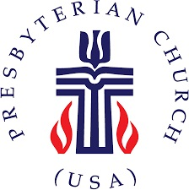
The Presbytery of Northern Waters
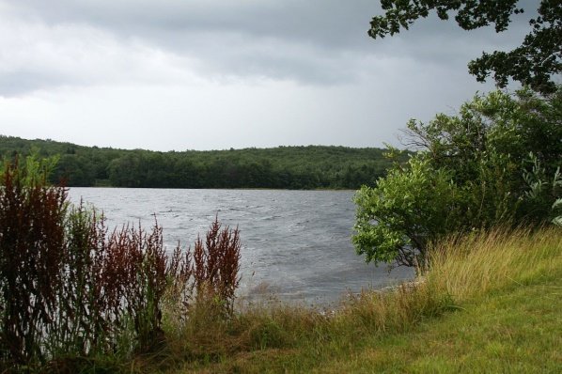

PRESBYTERY MEETING HIGHLIGHTS

The Presbytery of Northern Waters held its Fall Stated Meeting at Presbyterian Clearwater Forest on Friday and Saturday, October 25-26, 2019. These were beautiful fall days both inside and outside. We were welcomed warmly by the Clearwater Forest staff. There were about 50 people in attendance for our meeting.

We were blessed to be visited at this meeting by the Reverend Cindy Kohlmann, a co-moderator of the 223rd General Assembly (2018) of the Presbyterian Church (U.S.A.). She spoke about what’s going on in the national church and how the Presbyterian Church (U.S.A.) has an impact throughout the world. Reverend Kohlmann also preached during the Friday evening worship service, referring to how the Presbytery of Northern Waters can still be relevant despite our fewer numbers than in past years. She also participated in the installation of our new Presbytery Moderator and Vice Moderator.

Reverend Kohlmann encouraged our Commissioned Ruling Elders (CREs) to seriously consider attending a conference May 13-16, 2020 entitled “Empowering Commissioned Pastors”. Information can be found at https://www.pcusa.org/news/2019/10/19/co-moderators-223rd-general-assembly-2018-announce/ and from the Synod of the Sun. The Presbytery of Northern Waters has a scholarship fund that can provide up to 50% of the costs involved.

The featured speaker was the Reverend Ron Carlson, a retired Baptist pastor and professor. His topic was on how to view the Gospels from a Mission perspective. For example, Reverend Carlson asked, “How do you read Matthew? Consider reading the ending first and using that goal to help interpret the earlier parts of the book.

The Reverend Chris McCurdy, pastor of the United Presbyterian Church, Rice Lake, WI, was elected and installed as Moderator. Chris has been Vice-Moderator this past year. The Reverend Dorothy Duquette, pastor at the Lawron Presbyterian Church in Bovey, MN, was elected and installed as Vice-Moderator. The Ruling Elder Mary Voss, this past year’s Moderator moves to chair of the Presbytery Council for this next year (not elected but directed by the Bylaws).

Many other positions on committees were elected, but we still have a few of openings and encourage all to volunteer or suggest names of others to fill these positions. Please contact the Reverend Robyn Weaver, pastor at Duluth Glen Avon church, or the Presbytery office to volunteer.

The Committee on Ministry has approved a contract between the Reverend Ken Ribe and the Chippewa Falls church for Interim services. The call of the Reverend Brett Foote to the Superior, United church was also approved. This is Reverend Foote’s first call.

The Presbytery approved updated minimum salary standards for 2020 as recommended by the Committee on Ministry. The details will be sent to the churches soon, along with per capita statements for 2020.

A merger between the Carleton and Wrenshall churches is in the works. The last service in the Wrenshall building was held on September 25. These congregations are currently under the guidance of an Administrative Commission chaired by the Reverend Joel Huenemann.

We also have an Administrative Commission that is attempting to find a buyer for the Warba, MN church building. That congregation has closed.

The Presbytery approved an addition to the Manual of Operations that provides expectations and guidance for pastors, congregations, and the Presbytery when a pastor discontinues his or her services as pastor to one of our churches. These Separation Ethics guidelines were modeled after similar policies in other presbyteries.

The Finance and Budget Committee presented the recommendation of the 2020 budget. This budget calls for per capita apportionment totaling $32.00 for each member as of 12/31/2018, the same amount as for 2019. The GA did not raise their per capita amount and the Presbytery will absorb the 10 cent increase this year from the Synod. The recommended allocation of mission contributions remain at 20% to GA, 10% to the Synod, and 70% to the Presbytery. The budget includes a projected $22,195 deficit which will be made up primarily by our history of not spending every budgeted dollar. The Presbytery approved the budget. For the first 9 months of 2019, the Presbytery is showing a deficit of $9,679 compared to a surplus of $11,602 at this time last year.

The Reverend Rich Blood indicated that he is once again organizing a PDA mission trip in the coming months, likely to Lafayette, LA, Feb 15-23. The average cost to send these volunteers is about $350 per person. We are looking for congregations and individuals willing to contribute to a fund to minimize the cost to the participants. Please contact him at reblood@msn.com for details as they are finalized.

Saturday morning, during breakfast, the Board of Clearwater Forest presented their plan for a capital funds drive over the next 3 years. They are planning to raise $2.2 million for a combination of building improvements and additions to their endowment. The largest amount will be to renovate and expand Hallet Hall which houses the dining hall, kitchen, and camp offices. All who love Clearwater Forest are encouraged to contribute to this cause. (Isn’t that ALL of us?)

Any of the reports from the meeting can be sent to you by contacting either Jay Wilkinson (j.jay.wilkinson@gmail.com) or Amanda at the Presbytery office (office@northernwaters.net) or by calling the Presbytery office.

Next meeting: Saturday, February 1, 2020 at United Presbyterian Church, Superior, WI. We hope to see you there. All are encouraged to attend!

