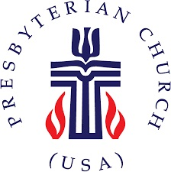
The Presbytery of Northern Waters
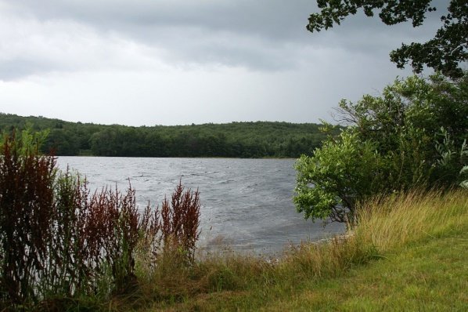

PRESBYTERY MEETING HIGHLIGHTS

The Presbytery of Northern Waters held its Winter Stated Meeting at the Lakeside Presbyterian Church, Duluth on Saturday, February 2, 2019. The weather, fortunately, had warmed considerably from the Polar Vortex that gripped the area only 2-3 days earlier. There were 55 people in attendance for our meeting and were warmly welcomed by members of the host church.

Vice Moderator Chris McCurdy offered to conduct a brief orientation for first-time commissioners, but none were present at that time. We plan to continue this tradition so that new commissioners have a better chance to understand what goes on at the Presbytery Meeting. We did have three first-time pastor members of the Presbytery: Kate Stangl, serving the Virginia church, Lindsay Biddle, a chaplain in Duluth, recently returned from 15 years in Scotland, and Gary Terrio, an ELCA pastor serving the Cloquet church. Reverend Biddle was received into the membership of the Presbytery at this meeting.

The featured speaker was the Reverend Robyn Weaver, pastor of the Glen Avon Presbyterian Church, Duluth. She led a very useful workshop on Active Listening encouraging us to be aware of blocking techniques that keep us from truly hearing what others are trying to communicate and helping us to use other language to be sure we understand.

We also had a presentation by the Reverend Doug Paulson, ELCA, Director of the Twin Ports Seafarers who assist foreign ship crews with their needs, including spiritual needs, while in port with little or no free time.

The Reverend Karen Schuder spoke on behalf of the Self Development of People Committee (SDOP) about what type of projects are eligible for funding and about two local projects in particular: New Hope for Families, and The Express Yourself Project. SDOP is one of the recipients of the One Great Hour of Sharing special offering annually.

The Reverend Jim Deters, co-chair of the Committee on Ministry (COM), plans to write a letter encouraging all pastors and Ruling Elders to live by their ordination vows to participate in the governance of the more inclusive Councils of the church, particularly the Presbytery. Attendance by both pastors and commissioners of the churches needs to improve. For example, of more than 60 minister members of the Presbytery, only 21 attended this meeting and of 52 churches in the Presbytery only 15 were represented by Ruling Elders. COM will also be requesting that all churches share with the Presbytery contact information lists for those currently serving on Sessions and encourage sharing their full member ship lists and contact information.

The Overtures and Bylaws Committee (O&B) recommended approval of an addition to the Manual of Operations to make it clear who has the authority to approve expenditures from the Presbytery portion of the Peace & Global Witness special offering (formerly known as Peacemaking). The Presbytery approved giving this authority to the Presbytery Council which has now approved a $2,000 grant from this fund for The Express Yourself project (see SDOP in the previous paragraph).

O&B also recommended approval of all the amendments to the PCUSA Constitution proposed by the 223rd General Assembly (2018). All were approved by the Presbytery except for amendment 18-C. For detail on the amendments, please see http://www.pcusa.org/site_media/media/uploads/oga/pdf/ga223_proposed_amendments_to_the_constitution2018.pdf .

Treasurer Jay Wilkinson spoke to the year-end financial statements and to the written report submitted by Finance & Budget Committee Chair Bill Gravelle. We ended the year with a deficit of $5,810 compared to a budgeted deficit of $4,245. The primary reason is due to the poor performance of investments in the 4th quarter 2018 which led to the first yearly loss on investments in several years.

In May, the Presbytery will be offering the Boundary Training that is required of all Teaching Elders and recommended for all Ruling Elders. This is scheduled for 2-5 p.m. on May 3 in Phillips, WI the afternoon before the spring Presbytery Meeting. It will be offered again in the Duluth/Superior area from 1-4 p.m. on May 9. More information and registration materials will be distributed in early April.

There will also be a Resiliency Workshop offered for Teaching Elders from noon on April 24 to noon on April 26 at Glen Avon Presbyterian Church in Duluth.

Any of the reports from the meeting can be sent to you by contacting either Jay Wilkinson (j.jay.wilkinson@gmail.com) or Ann at the Presbytery office (office@northernwaters.net) or by calling the Presbytery office (715-394-6265).

Next meeting: Saturday, May 4, 2019 at the First Presbyterian Church, Phillips, WI. Hope to see you there.

