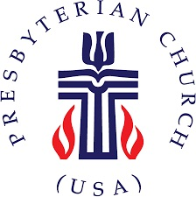
The Presbytery of Northern Waters
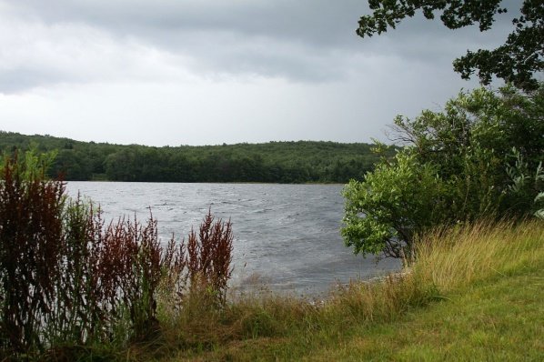

PRESBYTERY MEETING HIGHLIGHTS

The Presbytery of Northern Waters held its Annual Stated Meeting on Friday, October 9, 2020 via Zoom Video Conference due to the current pandemic restrictions on in-person meetings. This was the first stated meeting of the Presbytery held in this manner. The Presbytery leadership was a bit anxious as to how it would be received and how many people would choose to participate. While there were a few hiccups along the way (some of which this author probably did not even realize), the meeting generally went well. A few comments were made that this format allowed some people at the far reaches of the Presbytery to attend without spending a lot of time driving, often with an overnight stay. There was also a comment that this was one way the Presbytery could reduce our “carbon footprint” with significantly less fuel burned driving to meetings. The Presbytery Council will debrief this experience at its November meeting to see how we can improve the experience and whether to recommend that some of our meetings continue to be held in this manner after the pandemic is concluded, especially at times of the year when driving is likely to be difficult. The February 2021 meeting will likely be this same format.

Attendance was 55 people, the same number that attended the February 1 meeting at United Presbyterian Church, Superior. A concerted effort was made to reduce the amount of time spent in the business portion of the meeting with all committees submitting as much of their business as possible for a “consent agenda” that was dealt with quickly.

William McConnell, Mission Engagement Advisor – Central Region of the Presbyterian Mission Agency spoke with the Presbytery about the Matthew 25 initiative (4 of our congregations have made this commitment) as well as 10 of our congratulating congregations and the Presbytery who participate in all 4 of the special offerings of the denomination.

The Committee on Ministry brought actions related to the dissolution of the pastoral relationship between the First Presbyterian Church, Duluth and the Reverend Jeremiah Knabe. The Presbytery approved the formation of an Administrative Commission to assist the Session and the congregation in the upcoming months.

The Finance & Budget Committee submitted the report of outside auditors for the financial reports of 2019. This is normally presented at the Spring meeting, but that meeting was cancelled. The complete report is available either on the password protected portion of the website or by contacting the Presbytery office or the Presbytery Treasurer. Also, the 2021 budget was approved with no increase in per capita amounts. This is the 3rd year with no increase in per capita apportionment. It remains at $32.00 per member (for 2021, membership as of 12/31/2019).

The Presbytery elected the Reverend Dorothy Duquette (Lawron Presbyterian Church, Bovey, MN) as Moderator (she has been Vice Moderator this past year) and the Reverend James Deters (United Presbyterian Church and First Congregational Church, Ashland, WI) as Vice Moderator. The Reverend Chris McCurdy, the former Moderator, has become Chair of the Presbytery Council. The Reverend E Bradley Carloss was re-elected as Stated Clerk for another 3-year term and Ruling Elder Jay Wilkinson was re-elected as Treasurer for another 3-year term. The Moderator, Vice Moderator, and Chair of Council positions were effective upon installation later in the meeting. The Stated Clerk and Treasurer terms begin on January 1, 2021.

The Nominating Committee also presented a slate of chairs of committees and new members of committees, the details of which can be seen when the Minutes are available and posted to the website. These positions were effective at the end of this meeting.

The guest speakers following a lunch break were the Reverends Tyler Sit and Brian Schroeder from the Twin Cities. Their workhop was "Using Lean Startup to Move Your Worship Forward." Starting new ministries is core to Jesus' vision for the church. But how can you get started if you aren't well trained, ultra funded, or widely followed? Using Lean Startup methodology, we will explore how to start the ministry you're called to without breaking yourself in the process. We intended to record this presentation and to make it available to the churches in the Presbytery, but someone (who will remain nameless—this was one of those hiccups) forgot to hit the record button in Zoom.

During the closing worship, led by the Reverend Chris McCurdy, the new Moderator and Vice-Moderator were installed. The offering is made difficult by the nature of the meeting, but all who wish to contribute are asked to mail their donation to the Presbytery office with the notation of Presbytery Meeting Offering. It will be divided between the Peace & Global Witness and Christmas Joy offerings.

Any of the reports from the meeting can be sent to you by contacting either Jay Wilkinson (j.jay.wilkinson@gmail.com) or Amanda at the Presbytery office (office@northernwaters.net) or by calling the Presbytery office (715-394-6265).

The next meeting is scheduled for Saturday, February 6, 2021 and will likely be this same format.

