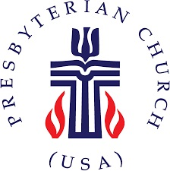
The Presbytery of Northern Waters
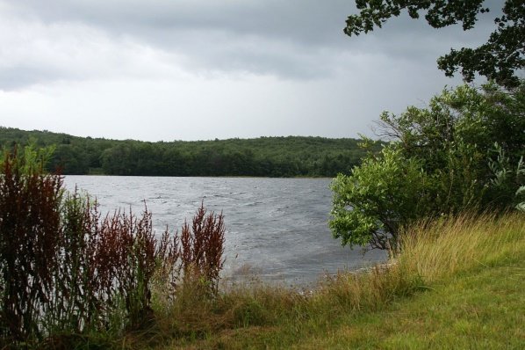

PRESBYTERY MEETING HIGHLIGHTS

The Presbytery of Northern Waters held its Spring Stated Meeting at the First Presbyterian Church, Phillips, WI on Saturday, May 4, 2019. It was a beautiful spring day! There were about 55 people in attendance for our meeting and were warmly welcomed by members of the host church. Presbytery meetings are more about connecting with friends and colleagues than about conducting business, even though it is necessary to do the business, as well. Just as we all get much out of worshipping together as congregations, we are all better because we are part of the Presbytery.

Moderator Mary Voss and the Council are encouraging each congregation to decorate a fabric square with some message of the mission of their church by August 1 so these can be incorporated into a mission quilt to be shared among the churches. If your church did not receive such a fabric square and instructions at the meeting, please contact Mary Voss and request yours (before we seek YOU out!)

Vice Moderator Chris McCurdy conducted a brief orientation for first-time commissioners. We plan to continue this tradition so that new commissioners have a better chance to understand what goes on at the Presbytery Meeting. We did have several people attending their first Northern Waters Presbytery meeting.

The featured speaker was the Reverend Rhonda Kruse, Midwest Mission Engagement Advisor from the Presbyterian Mission Agency. Her talk was about both Per Capita Apportionment and Mission. Per Capita is a fundamental way that we work together and share in the work of the whole church. Most of our per capita payments go toward expenses of the Office of the General Assembly (OGA) and some of the expenses included are the biannual General Assembly, the office of the Stated Clerk, Constitutional Services, Immigration Services, Church Leadership Connection, and assistance to Committees on the Preparation for Ministry including ordination exams.

A major portion of Rhonda’s message regarding mission centered around the current program of promoting the Matthew 25 initiative. Matthew 25:40: “. . . Truly I tell you, just as you did it to one of the least of these who are members of my family, you did it to me.” The purpose is threefold: To connect and unite the PCUSA, to celebrate & call forth disciples, and to clarify the understanding of Christians in the PCUSA. Please see www.pcusa.org/matthew25 .

Reverend Kruse commended 7 congregations in the Presbytery as “4 for 4” congregations. These congregations participated in all four of the denomination’s special offerings. They are: Lawron, Brule, Lakeside, Eau Claire, First, Phillips, Country Peace, and Wrenshall. In addition, the Presbytery was commended for contributing to all four special offerings from the offerings taken during worship at our Stated Meetings.

In addition to numerous reports from Presbytery committees, the annual review of our financial statements by independent accountants (the firm of Anderson, Kuiti, & Asuma, CPAs of Duluth) was received.

The Reverend John Mann was received by the Presbytery from the Church of Scotland from which he retired recently. Reverend Mann was previously a member of the PCUSA (most recently the Presbytery of the Twin Cities Area) and has returned to retire in the US along with his wife, the Reverend Lindsay Biddle who was received into membership in the Presbytery previously.

Unfortunately, Ann Gerlich who has been a faithful servant of the Presbytery for 2 ½ years and longer for Pioneer Parish, is leaving us at the end of May due to a transfer for her husband to the Madison area. Ann’s ministry with us was celebrated and all present agreed that she will be greatly missed. The Personnel Committee is beginning a search to fill this hole.

On Friday afternoon before the meeting, the Presbytery offered the Boundary Training that is required of all Teaching Elders at least every 5 years and recommended for all Ruling Elders led by the Reverend Deb DeMeester from our synod staff. This will be repeated at Glen Avon Presbyterian Church, Duluth from 1-4 p.m. on May 9.

There was also be a Resiliency Workshop offered for Teaching Elders April 24 to 26 at Glen Avon Presbyterian Church in Duluth. Presbyter for Pastoral Care Ken Ribe was the organizer and gave a summary at the Presbytery meeting.

Any of the reports from the meeting, including the report of the auditors, can be sent to you by contacting either Jay Wilkinson (j.jay.wilkinson@gmail.com) or Ann at the Presbytery office (office@northernwaters.net) or by calling the Presbytery office (715-394-6265).

Next meeting: Friday and Saturday, October 25-26, 2019 at Presbyterian Clearwater Forest, Deerwood, MN. We hope to see you there.

